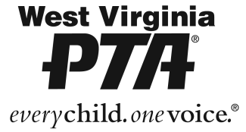
2026 West Virginia PTA Scholarship Rules and Requirements
Scholarship Amount: $500

- The scholarship recipient(s) must be a high school senior in a WV school.
- Applicants must have a 2.0 grade point average.
- This scholarship must be used for tuition/educational expenses in any vocational, college or institution of higher learning approved by the Scholarship Committee. It may not be used for living or personal expenses.
- The scholarship recipient may accept another source of financial aid or scholarship.
- A high school transcript must be submitted with the application.
- Scholarship Application form must be received by February 1, 2026.
- The final decision on awarding a scholarship shall be made by the Scholarship Committee comprised of members of the West Virginia PTA Board of Managers and PTA members appointed by the President.
- Payment of the scholarship shall be in the form of a check made payable to the approved school to be used for tuition/educational expenses only.
- Criteria for Selection of Scholarship Recipient(s):
- Overall quality of application, submitted materials, and following directions.
- Volunteer Service, Leadership, Honors Received, Extra-Curricular Activities, and Workforce.
- Recipient shall be selected without regard to race, color, religion, sex, national origin, disability or geographical location.
- Checklist:
☐ 2026 application completed and submitted via the online form (NO PREVIOUS YEAR APPLICATIONS WILL BE ACCEPTED).
☐ Official Transcript
☐ PTA Reflection (one page limit)
☐ Long-Term Goals Essay (one page limit)
☐ Letters of Recommendation (no more than three, one page each). Examples: Teachers, Community Leader, Job Supervisor.
For further information please email: scholarship@westvirginiapta.org

To access the scholarship area of the website containing the application link, scan the QR code.

